LEGENDS OF BOXING SERIES: IN HONOR OF PAT KELLY

Boxing Ontario has secured two (2) hotels with a Group Discount and the information is below.
NOTE: Please state that you are from the Boxing Ontario Group when reserving a room

Hotel – Ramada Fallsview

Address: 6045 Stanley Ave, Niagara Falls

Reservation Information: call 1-877-374-4142 (**NEW**), press 0 for the Front Desk and request the Boxing Ontario block of rooms. A credit card is required to book definite. If cancellation occurs within 72hours prior to arrival a penalty to the individual of the first night’s room and tax will apply.

Deadline for the Boxing Ontario Group Discount: 10 Sept 2022

Date | Room | Rate
Friday, September 23rd, 2022 | 2 Queen Beds (30 rooms) | $129.00
Saturday, September 24th, 2022 | 2 Queen Beds (30 rooms) | $199.00
- These rates are based on availability.
- Room rates are on a per night basis and are net non- commissionable, in Canadian funds, based on single and double occupancy.
- The Hotel’s room rates are subject to the following mandatory fees/taxes: $4.99 per night facility fee, 13%HST, 4.5% DMC and $2.26 per night city accommodation tax.
- For triples and quads an additional charge of $10.00 per adult applies; children 18 and under stay for free.
- Discounted parking available at $15.00 per night, per vehicle.
- Check in Time: 4pm Check out Time: 11am
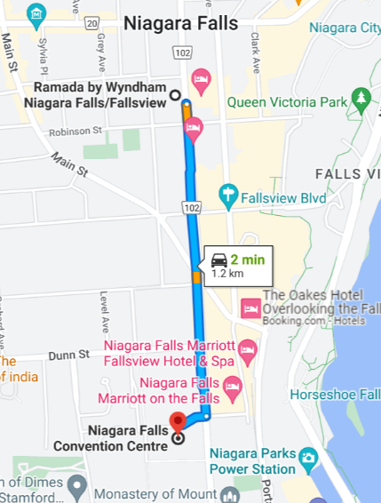
- Early Check out: Those members of your group that wish to check out prior to their scheduled departure date will be subjected to an early check out penalty. A charge of 100% of the agreed rate plus applicable taxes will be applied.

Directions:

Driving / Walking : Proceed down Stanley Ave and Niagara Falls
Convention Center is on your right

Time: 2 minute drive
15 minute walk

Niagara Falls Convention Center Parking:
Note: $10/day/vehicle

Hotel – Days Inn by the Falls

Address: 5068 Centre St., Niagara Falls

Reservation Information: call 905-357-2550 for the Front Desk and request the Boxing Ontario block of rooms. A credit card is required to book definite. Please be advised that the credit card on file is preauthorized prior to arrival for the full amount of stay plus a $100 CAD refundable deposit

Deadline for the Boxing Ontario Group Discount: 9 Sept 2022

Date | Room | Rate
Friday, 23 Sept 2022 | Single & Double | $149
Saturday, 24 Sept 2022 | Single & Double | $199

- Rates are net Canadian funds subject to 19% taxes + $2.26 City fee.
- The additional adult charge 14+ for triple & quad is $10.00 each.
- Onsite parking is $15.00 per day subject to 13% HST.
- Buffet breakfast is available daily in our Lobby Café at a cost of $9.95 subject to 13% HST. Breakfast opens at 7:30 a.m.
- Check in Time: 3pm Check out Time: 11am
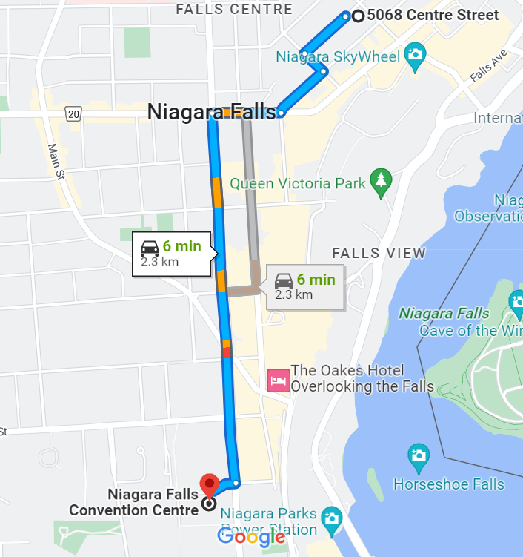
Directions:

Driving / Walking : Proceed southwest on McGrail Ave
toward Magdalen St.
Turn left onto Magdalen St.
Turn right onto Elle Ave
Turn right onto Ferry St.
Turn left onto Stanley Ave
Convention Center is on your right

Time: 6 minute drive
28 minute walk

Niagara Falls Convention Center Parking:
Note: $10/day/vehicle

